Signals & Communication Systems - Lab-4
Linear Convolution
Exercise 4.1: Determine analytically the convolution of the following signals, and verify
your answers using the Matlab.
x(t)=e−t⋅u(t)and h(t)=u(t)-u(t-1)
sol:
clc; clear; close all;
% time parameters
dt = 0.001;
t = -1:dt:8; % choose a window long enough to show response
% unit step
us = @(t,to) double(t>=to);
% signals
x = exp(-t).*us(t,0); % x(t)=e^{-t}u(t)
h = us(t,0) - us(t,1); % h(t)=u(t)-u(t-1) (width 1 rectangle)
% numeric convolution (scale by dt)
y_num = conv(x,h)*dt;
% time axis for convolution result: t_conv goes from t(1)+t(1) to t(end)+t(end)
t_conv = (t(1)+t(1)):dt:(t(end)+t(end));
% truncate/align to same viewing window as t
% (we'll compare on t_compare which lies inside t_conv)
t_compare = -0.5:dt:6; % region for comparison/plot
% analytic y(t) evaluated on t_compare
y_ana = zeros(size(t_compare));
% cases
idx1 = t_compare < 0;
idx2 = (t_compare >= 0) & (t_compare < 1);
idx3 = t_compare >= 1;
y_ana(idx1) = 0;
y_ana(idx2) = 1 - exp(-t_compare(idx2));
y_ana(idx3) = (exp(1)-1).*exp(-t_compare(idx3)); % (e-1)*e^{-t}
% extract numeric y for the same t_compare from y_num
% find indices in t_conv that correspond to t_compare
[~, idx_start] = min(abs(t_conv - t_compare(1)));
idx_end = idx_start + length(t_compare) - 1;
y_num_slice = y_num(idx_start:idx_end);
% plotting
figure('Position',[100 100 800 600]);
subplot(2,1,1);
plot(t, x,'b','LineWidth',1.5); hold on;
plot(t, h,'k','LineWidth',1.5);
legend('x(t)=e^{-t}u(t)','h(t)=u(t)-u(t-1)');
xlabel('t'); ylabel('Amplitude');
title('Signals x(t) and h(t)'); grid on;
axis([-0.5 6 -0.2 1.2]);
subplot(2,1,2);
plot(t_compare, y_num_slice,'r','LineWidth',1.5); hold on;
plot(t_compare, y_ana,'--b','LineWidth',1.5);
legend('Numerical conv (conv)','Analytical result');
xlabel('t'); ylabel('y(t)');
title('y(t)=x(t)*h(t) — numeric vs analytic'); grid on;
axis([-0.5 6 -0.05 1.2]);
% compute and display max absolute error
max_err = max(abs(y_num_slice - y_ana));
fprintf('Max absolute error between numeric and analytic y(t): %g\n', max_err); 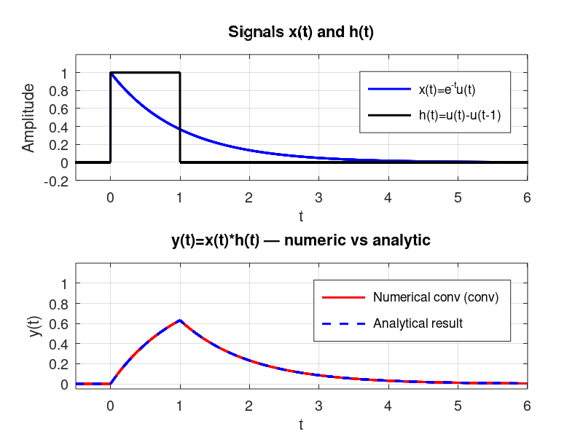

Exercise 4.2: Consider a continuous time signal shown below. Convolve the signal itself i.e., y(t)=x(t)*x(t). Determine analytically the convolution and verify your answers using the Matlab.
Sol:
t = -1:0.001:5;
x = us(t,0)-us(t,1);
h = us(t,0)-us(t,1);h = double(h);
y = (0.002)*conv(x,h);
% y = us(t,0)-exp(-2*t).*us(t,0);
t2 = -2:0.001:10;
figure();
subplot(3,1,1);plot(t, x,'b','LineWidth',3);
xlabel('time ----->');ylabel('Amplitude ----->');
title('x(t)'); axis([-1 5 -0.2 1.2]);
subplot(3,1,2);plot(t, h,'k','LineWidth',3);
xlabel('time ----->');ylabel('Amplitude ----->');
title('h(t)');axis([-1 5 -0.2 1.2]);
subplot(3,1,3);plot(t2, y,'r','LineWidth',3);
xlabel('time ----->');ylabel('Amplitude ----->');
title('y(t)=x(t)*h(t)');axis([-1 5 -0.2 1.2]);
Figure:
